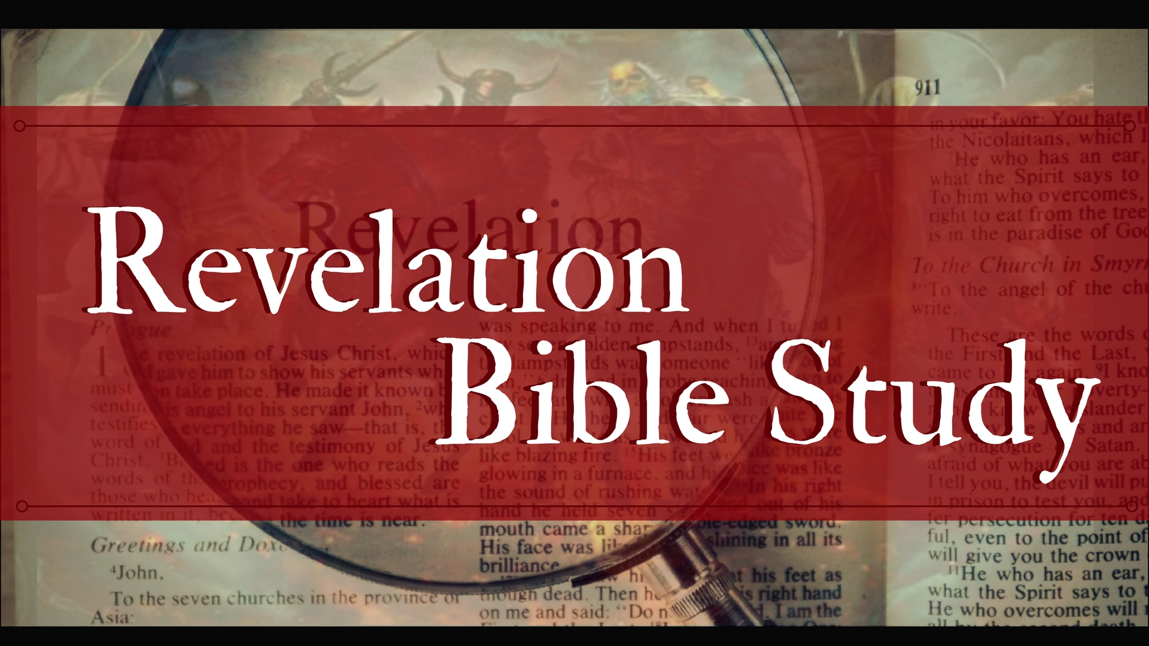
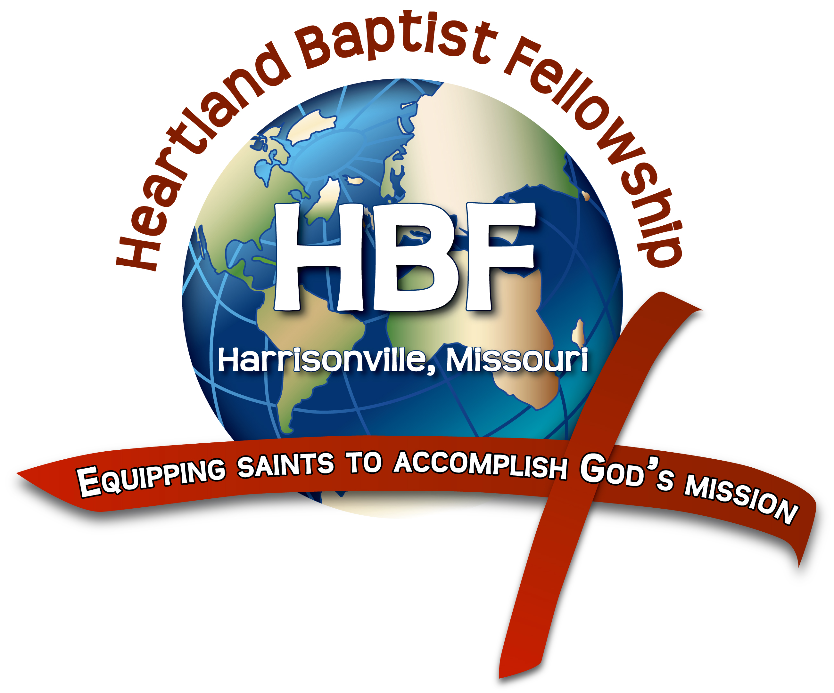
The Book of Revelation
Behold I Make All Things New
Revelation 21
Heartland Baptist Fellowship
August 29, 2018

Purpose: To increase our understanding of who God is and intensify our urgency in ministering the gospel in these last days.

There are also seven “New Things” found in Revelation 21-22

- The New Heaven Revelation 21:1
- The New Earth Revelation 21:1
- The New City Revelation 21:9-23
- The New Nations Revelation 21:24-27
- The New River Revelation 22:1
- The New Opportunity to take of the Tree of Life Revelation 22:2
- The New Throne Revelation 22:3-4

- Heaven and Earth Receive a R__________ Revelation 21:1

- New Jerusalem will receive a R_________ Revelation 21:2

- A Great Voice Makes a P__________ Revelation 21:3-8

- New Jerusalem’s D____________ Revelation 21:9-15

- New Jerusalem’s D____________ Revelation 21:16-17

- New Jerusalem’s D______________ Revelation 21:18-21

- New Jerusalem’s I______________ Revelation 21:18-21

- New Jerusalem’s H_________ Revelation 21:26-27

