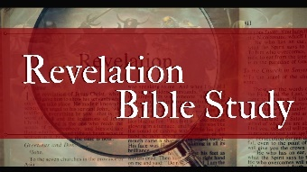The Book of Revelation
Mystery Babylon Religion
Revelation 18
Heartland Baptist Fellowship
July 11, 2018

Purpose: To increase our understanding of who God is and intensify our urgency in ministering the gospel in these last days.

Revelation 17 is the destruction of Religious Babylon
Revelation 18 is the destruction of Economic Babylon
Revelation 19 is the destruction of Militant Babylon (led by the Antichrist)

- The Proclamation of Babylon’s Reality Revelation 18:1-3

  - The Angel announces the ________ of Ecclesiastic and Economic Babylon. Revelation 18:1-2

  - Her (the cities) influence has influenced the ___________. Revelation 18:3, Job 41:12-13,

  - The _________ Babylon’s of Revelation 17-18 are hard to distinguish because they resemble one another so closely.

  - The next Babylon will likely match or exceed the ___________ of the first. Isaiah 13:20, Jeremiah 51:26

- The Proclamation of Babylon’s Finality Revelation 18:4-24

  - Her Earthly ____________ Revelation 18:4

  - Her ____________. Revelation 18:5-8, Daniel 4:11, Isaiah 47:7-8

  - Her Earthly ______________ Revelation 18:9-19

  - Hear Heavenly __________________ Revelation 18:20, 1 Peter 5:13

  - Hear Earthly ____________ Revelation 18:21-24

